Weekly Status Report CS442 – Project Team – 5
List of Completed Features :
- Control Computer mouse using Android Device with Wi-Fi connection
- Control Keyboard using Android Device
- User can open, save, edit text files in editor and also can access editor’s menu items
- Changing background of touchpad in android application. (not integrated in final application)
- Using mouse control user can perform single click, double click, right click .
List of Working Features :
• Control PPT presentation using Android Device • User can start slide show, forward-backward slides and exit slide show.

Test Cases after Phase 2 :
As shown in screen shot, while using app if use get a
call or any notification then it will show above the application.
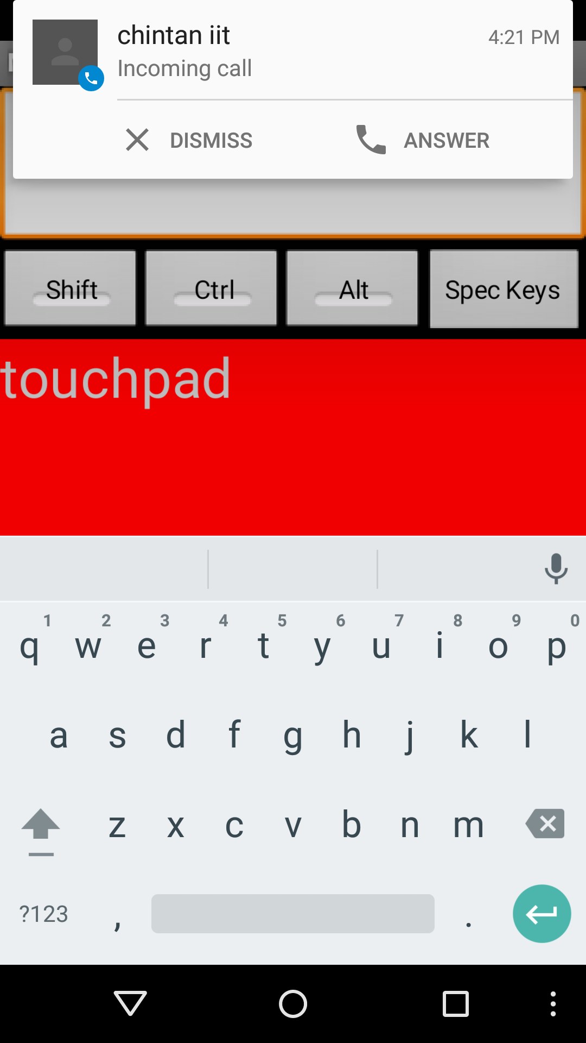
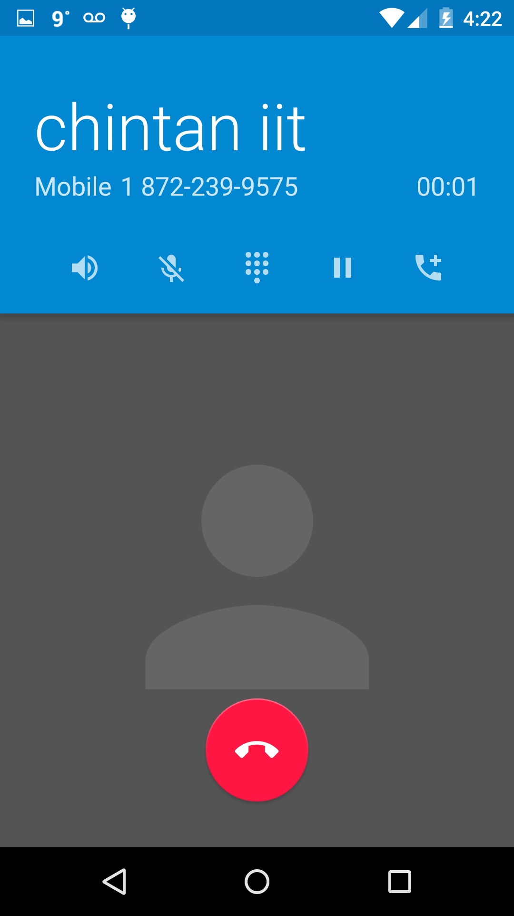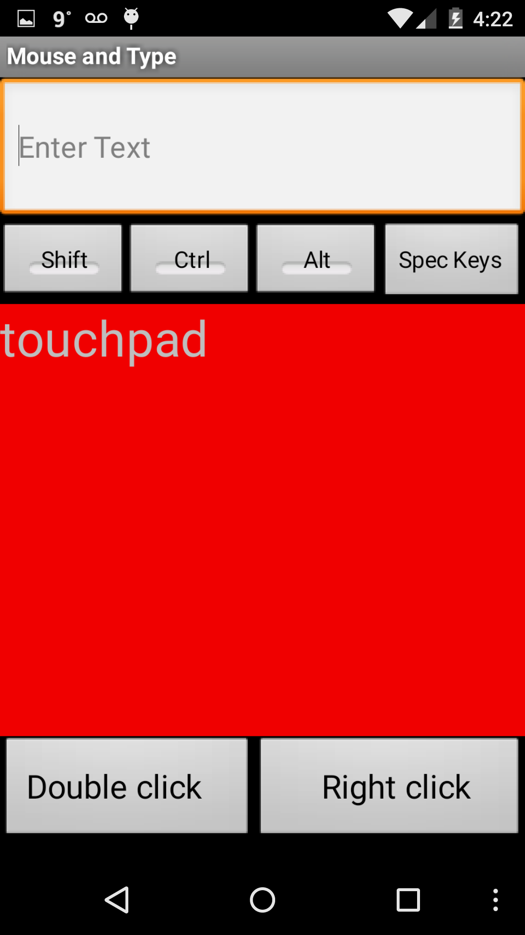
- User can answer calls while running application and after disconnect call application resumes as it is.
- We have tested application in android version 4.4 Kit- Kat and 5.0 Lollypop.
- If user use application anonymously , like try to perform mouse and keyboard simultaneously then because of connection hangs between device and computer it gives error in shown in screen shot.
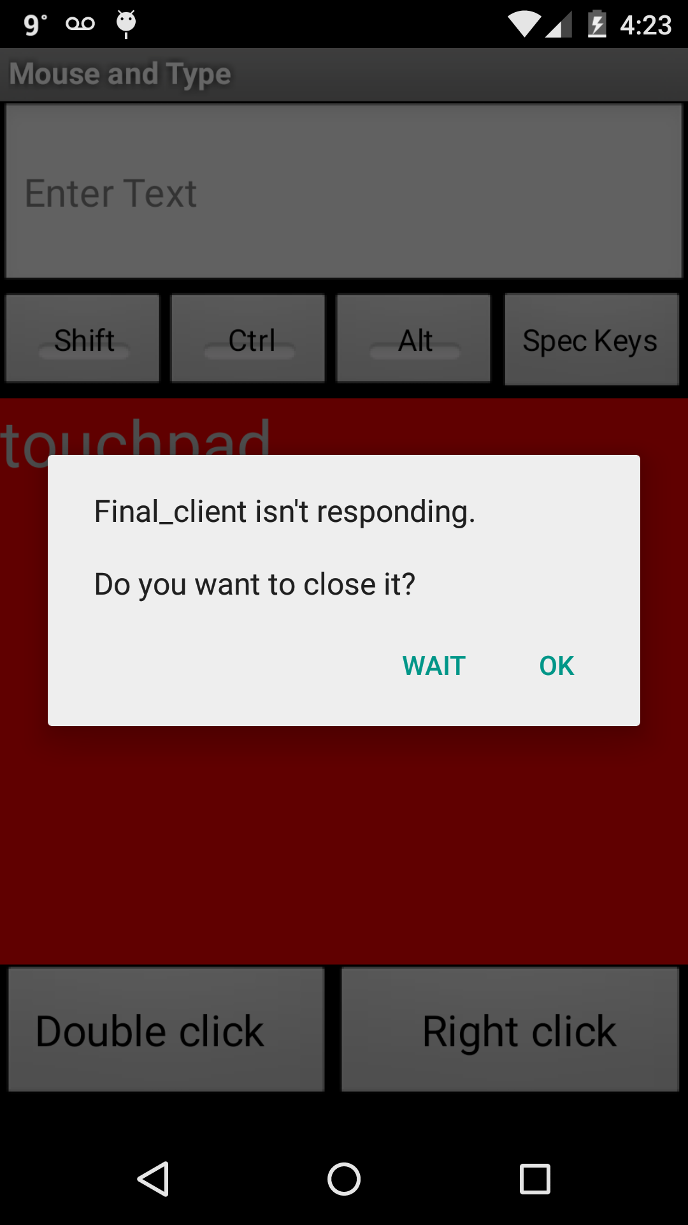
- Here if user press wait in error then after connection resumes, application works again.

